Ringfenced Invested Funds Application
Proposed by:
- Jamie Charles
- James O’Garro
Summary:
The original expected price for our second-hand aluminium punting pole was £100. However, these have now become out of stock, thus the JCR will need to pay £300 for a new wooden pole. Moreover, there has been an unforeseen additional cost of £50 for the supply and fitting of chains, vinyl lettering of punt names and registration numbers. Therefore, I consider it reasonable to apply for the extra costs (£250) to be withdrawn from the Ringfenced Invested Funds in order to maintain a healthier balance for the year’s One-Off Purchases.
We have been slightly disappointed in the communication with us regarding the increased punt costs, but following investigation by the JCR Treasurer, have concluded that there is no prospect of a better price for the pole, and therefore conceded that our best option is to pay this increased cost. I believe that given the increase in costs, a slightly increased withdrawal is in the spirit of what students voted for in the ballot on making the original withdrawal from the fund to cover the cost of building the punt and its first year’s upkeep costs.

Motion:
That £250 from the Ringfenced Invested Funds be used to fund the price discrepancy that has occurred from the original quote for punt costs

Previous Invoice:
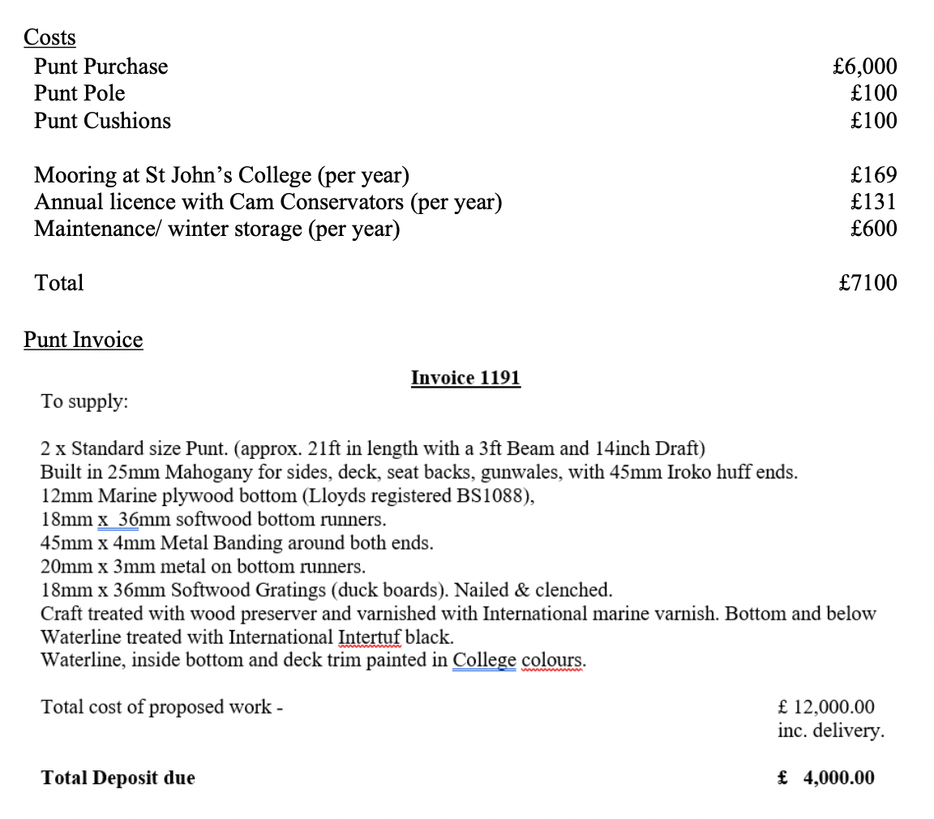

Updated Invoice:
